How to access the internet using an eSIM on a Google Pixel device?
If you experience internet connectivity issues after installing an eSIM on your Google Pixel device, ensure you have completed the "Access Data" step for your eSIM.

You can find the relevant steps in your eSIM account:

1. Open the eSIM app.

2. Tap My eSIM.

3. Tap the eSIM you want to install.

4. Tap View instructions.
5. Find the Access Data instruction.
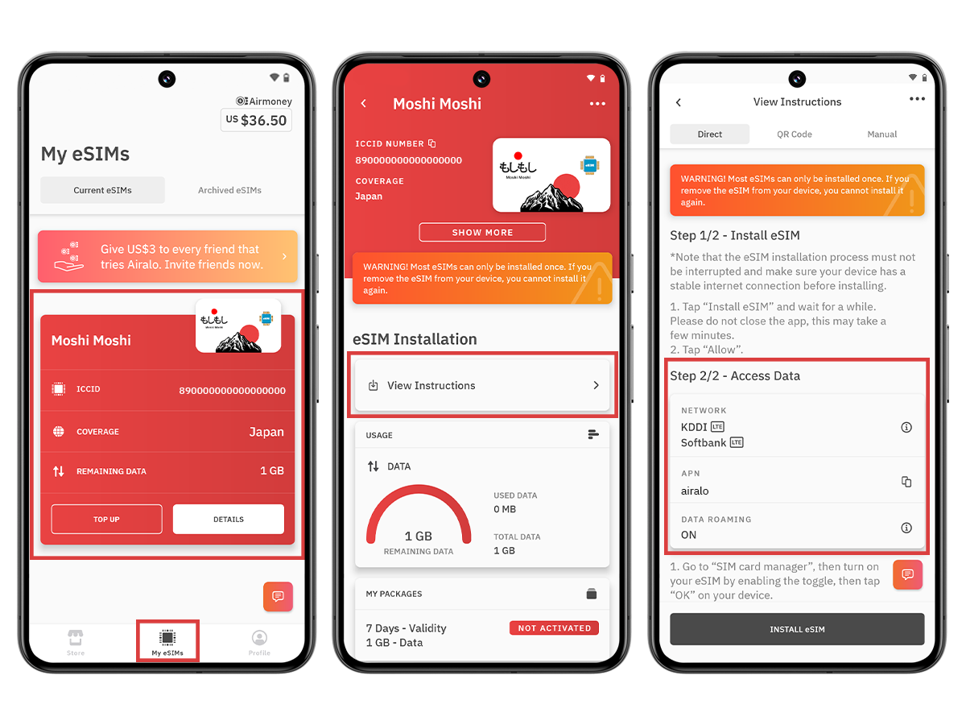
Before proceeding with the following steps, ensure your eSIM number is enabled and selected for mobile data.

1. Go to Settings.

2. Go to Networks & Internet.

3. Tap SIM cards.

4. Ensure your eSIM is enabled. If not, enable it.
5. Turn on Mobile Data.
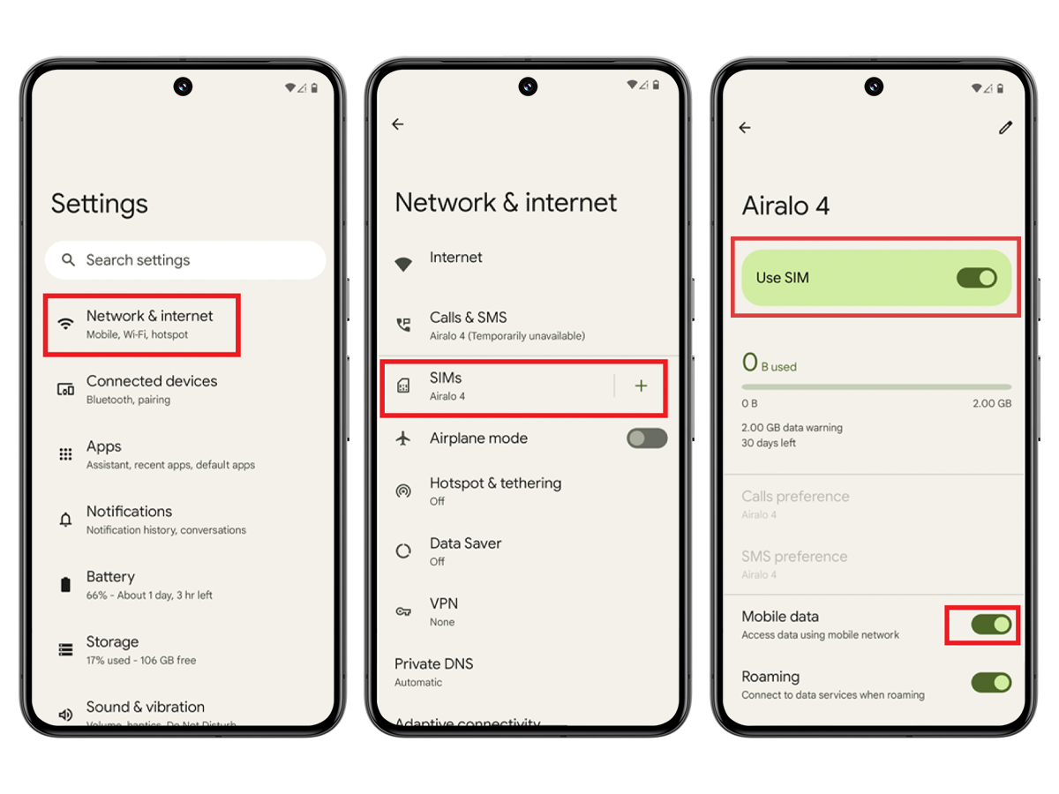
Connect to a supported network:

1. Go to Settings.

2. Go to Networks & Internet.

3. Tap SIM cards. 4. Tap your eSIM.

5. Disable automatic network selection.
6. Select the network specified in your eSIM's access data information. 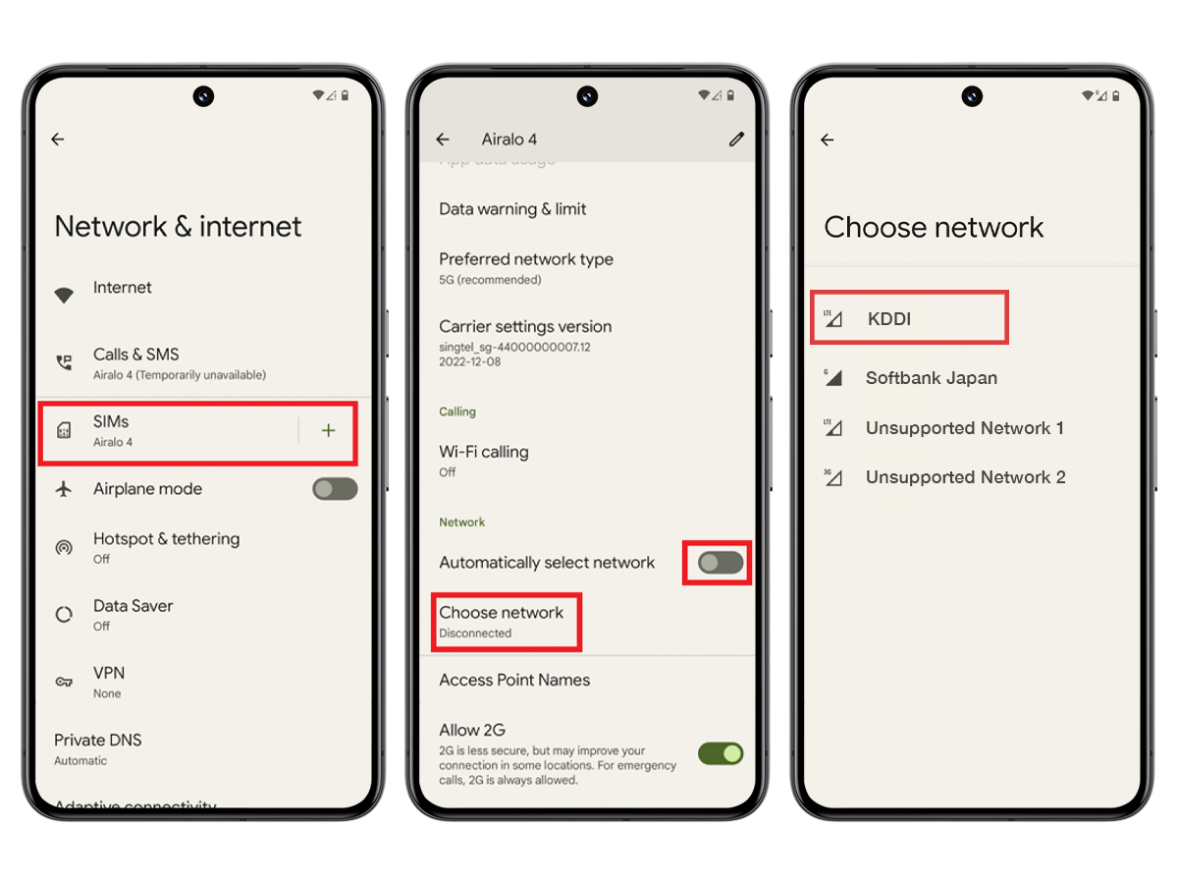
Update APN settings (if needed):
Open the eSIM app and review the eSIM instructions to check if you need to modify the APN on your device.

1. Go to Settings.

2. Go to Networks & Internet.

3. Tap SIM card.

4. Tap your eSIM.

5. Tap Access Point Names.

6. Tap the + icon.

7. Enter the new APN in the APN field.

8. Tap OK.

9. Enter eSIM as the APN label in the Name field.

10. Leave the other fields blank.

11. Tap the three-dot menu in the upper right corner.

12. Tap Save.
13. Ensure the added APN is selected.
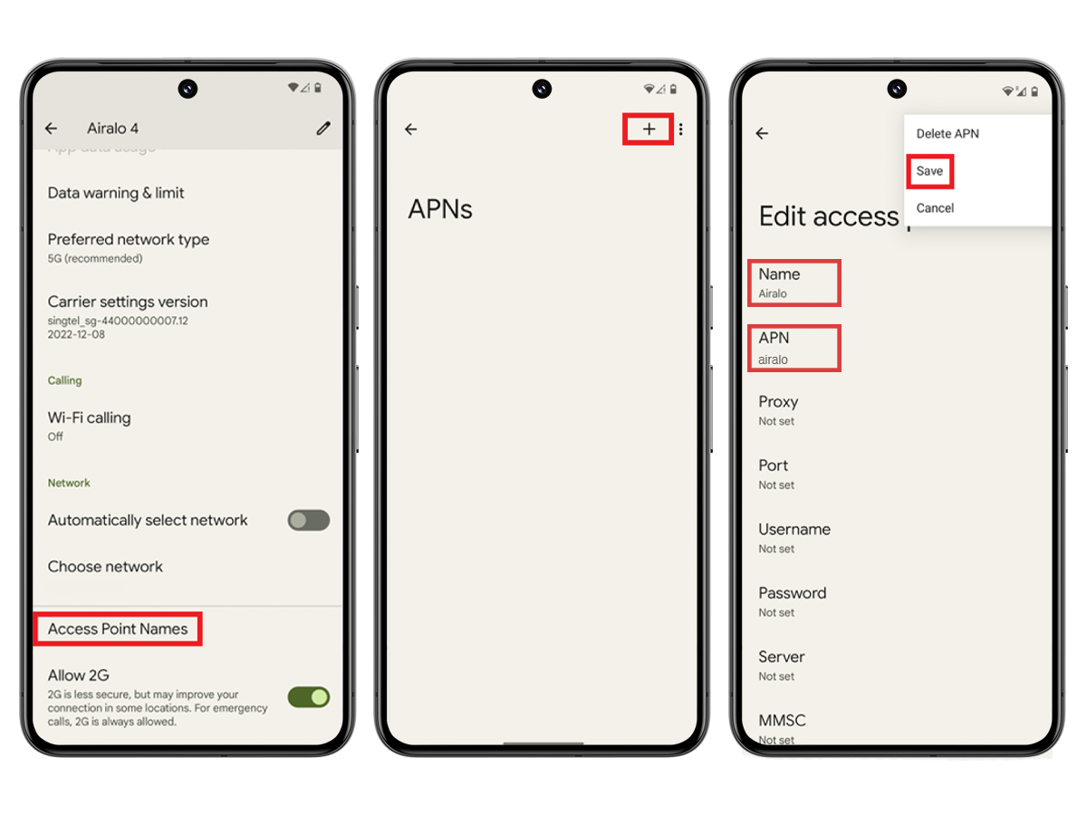
To enable data roaming (if needed): Open the app and review the eSIM instructions to check if you need to enable data roaming on your device.

1. Go to Settings.

2. Go to Networks & Internet.

3. Tap SIM card.

4. Tap your eSIM.
5. Toggle Roaming on or off.
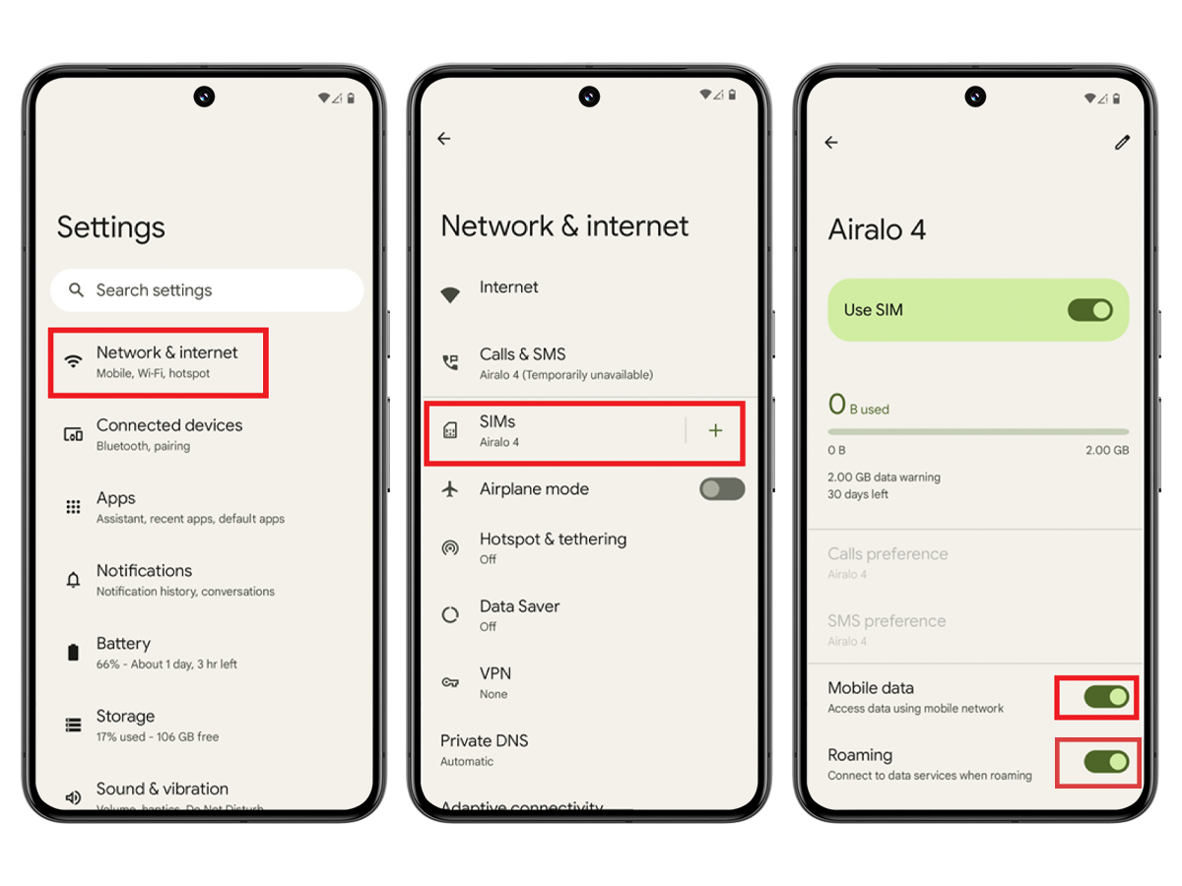
After following the instructions correctly, your eSIM should successfully connect to the internet.

For further assistance, please contact our support team; we'd be happy to help.

